**BDA LAB 1 -3**

**For the following tables created perform the following:**

Perform the following DB operations using MongoDB.

1. Create a Collection “Student” with the following attributes Rollno, Age, ContactNo, Email-

Id.



2. Insert appropriate values

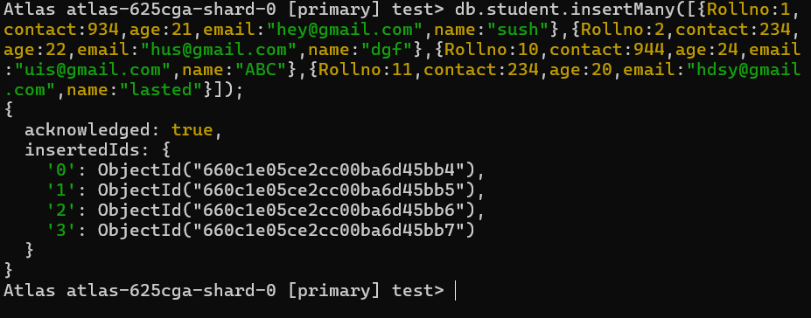

3. Write query to update Email-Id of a student with rollno 10.

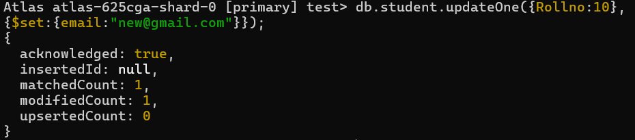

4. . Replace the student name from “ABC” to “FEM” of rollno 11

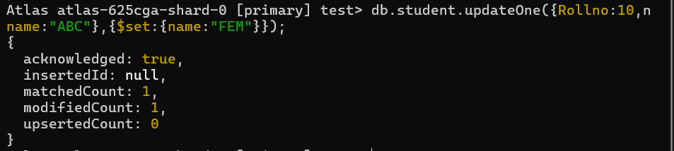

5. Display Student Name and grade(Add if grade is not present)where the _id column is 1.

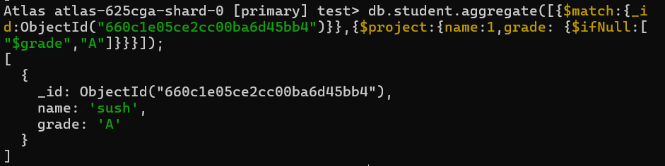

6. Update to add hobbies

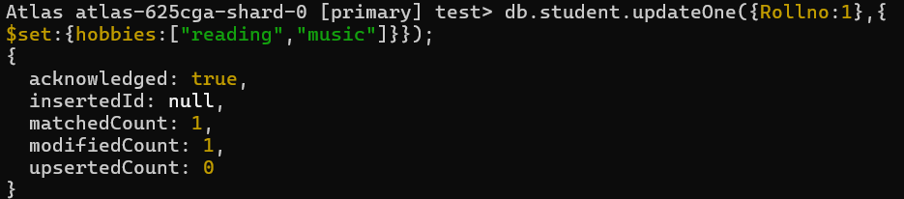

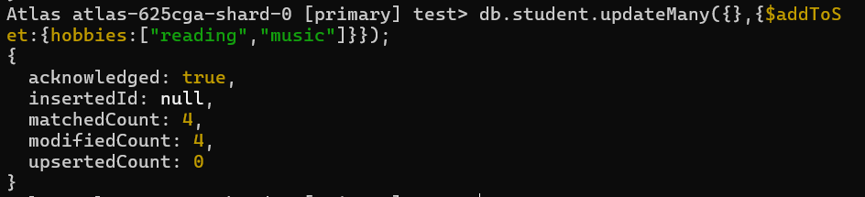

7. Find documents where hobbies is set neither to Chess nor to Skating

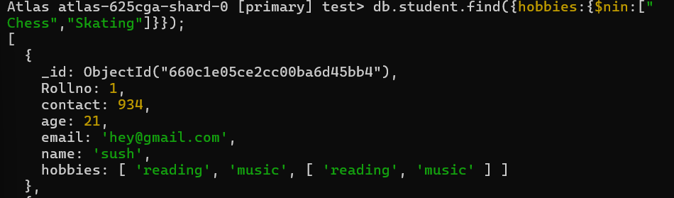

8.Find documents whose name begins with F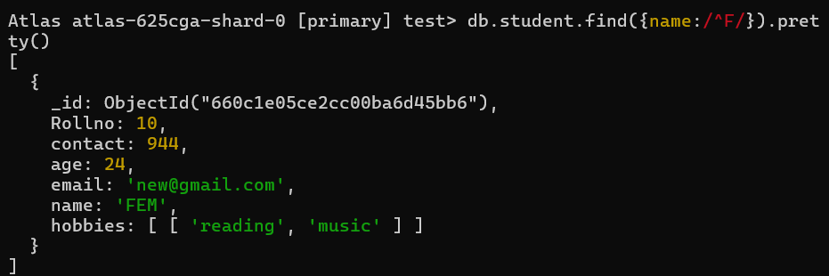

Exercise 2:

II. Perform the following DB operations using MongoDB.

1. Create a collection by name Customers with the following attributes.

Cust_id, Acc_Bal, Acc_Type

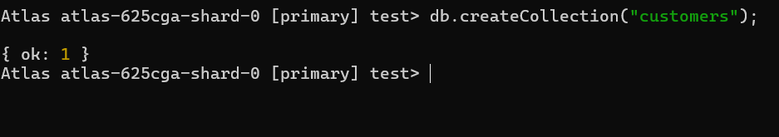

2. Insert at least 5 values into the table

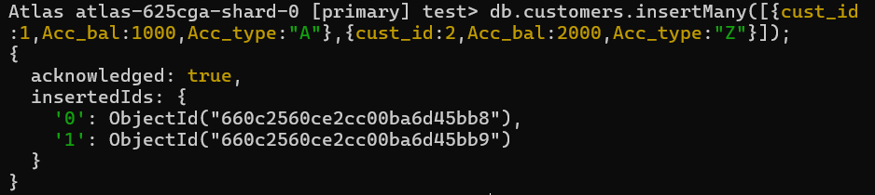 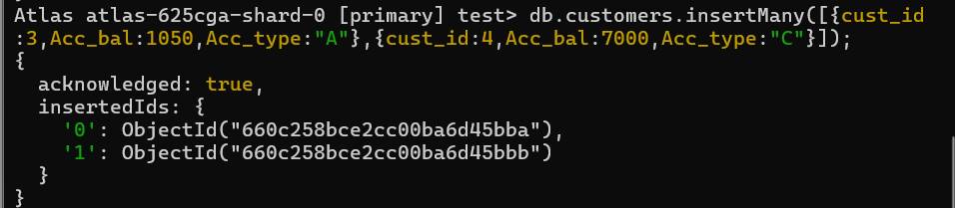 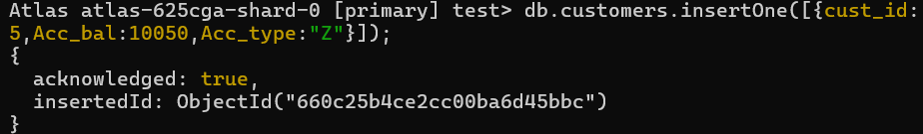

3. Write a query to display those records whose total account balance is greater than

1200 of account type ‘Z’ for each customer_id.

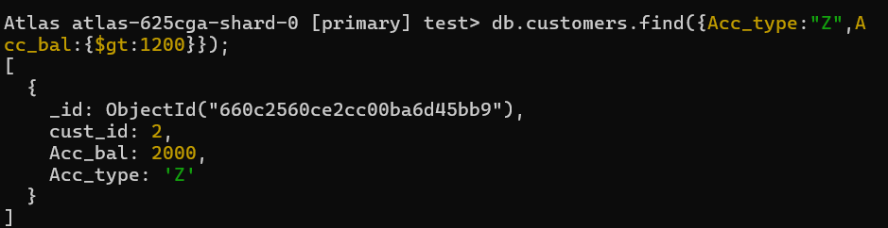

4. Determine Minimum and Maximum account balance for each customer_i

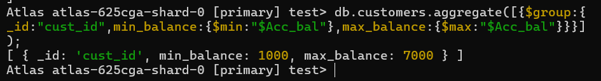

5. Sort the documents based on Customer ID in ascending order and Account Balance in descending

Order

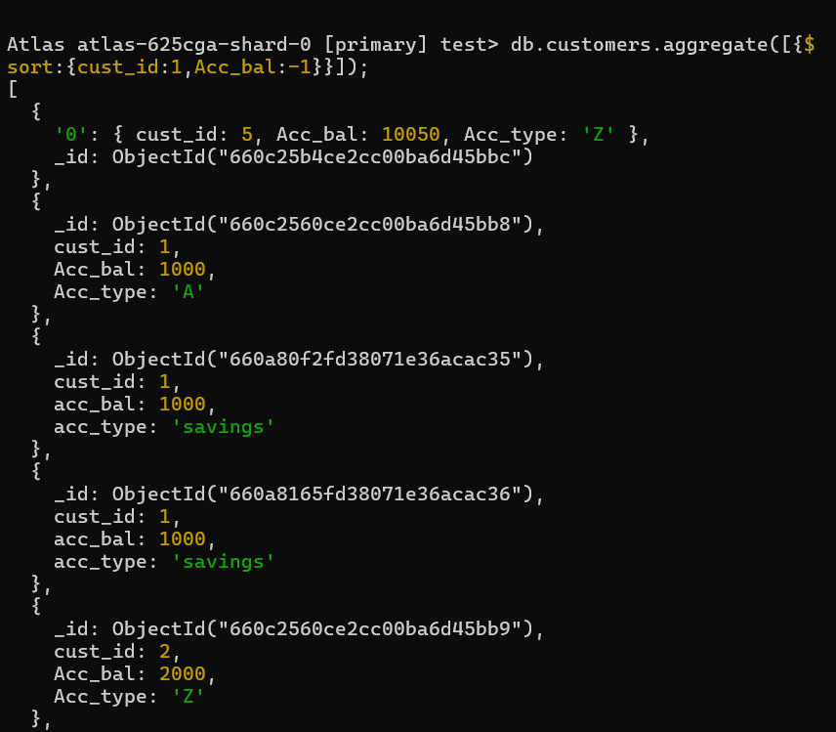Note: the documents are sorted first by customer_id in ascending order, and within each group of documents with the same customer_id, the balance is sorted in descending order.

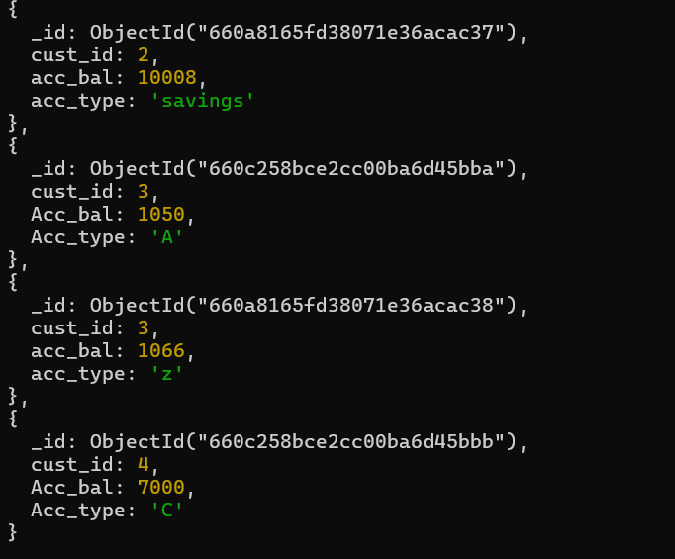

6. Display only 2 nd and 3 rd records from the collection

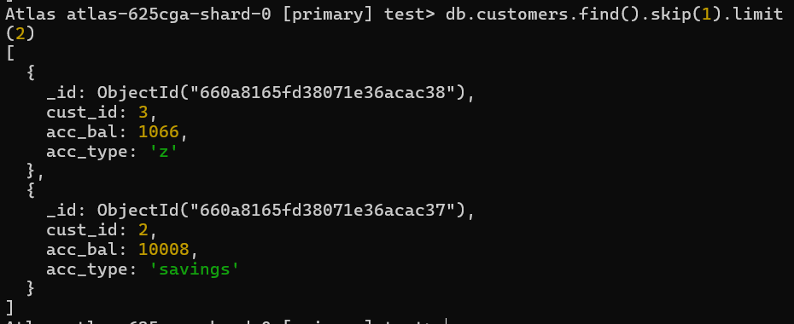

Exercise 3: